IPC8MSD2R8-I2
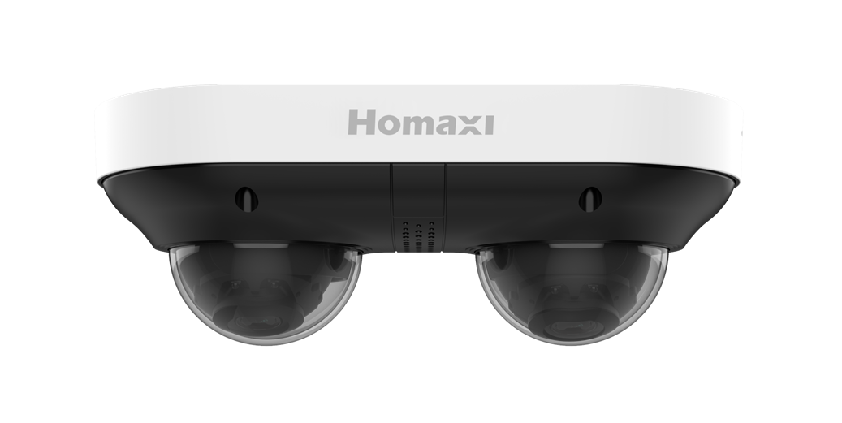
2 x 4MP Dual-Directional PanoVu Camera

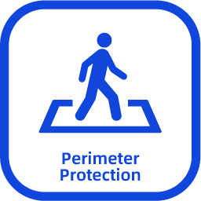
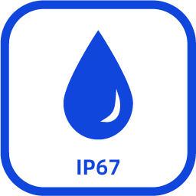

Key Features

- High quality imaging with 4 MP resolution
- 3D DNR technology delivers clean and sharp images
- Supports 2-channel WDR to realize clear imaging against strong back light
- Efficient H.265+ compression technology
- Water and dust resistant (IP67) and vandal resistant (IK10)
- Built-in dual-microphones for real-time audio security
- Easy installation with Power over Ethernet (PoE) technology

Dimensions
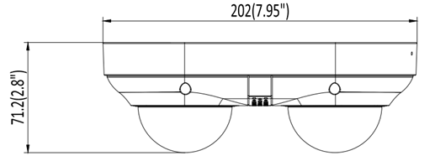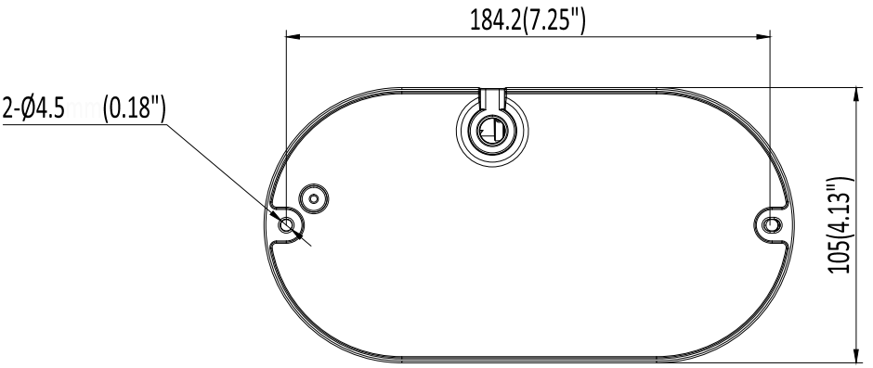

Specification

Camera
Image Sensor | 1/2.7" Progressive Scan CMOS Sensor
Min. Illumination | Color: 0.006 Lux ( F1.6, AGC ON ) , 0 Lux with IR lights on
Illumination Distance | 30m ( IR light )
Strobe Light | N/A
Smart IR | Support
Pan/Tilt/Rotation Range | Pan: -90° ~ 90°  Tilt: 0° ~ 60°  Rotation: 0° ~ 355°
Lens
Focal Length | 2.8mm
Aperture | F1.6
FOV | 2.8mm@F1.6 Horizontal FOV: 101°, Vertical FOV: 55°, Diagonal FOV: 121°
Lens Mount | M12
DORI
DORI | 2.8mm@F1.6, D:71m , O:28.4m , R:14.2m , I:7.1m
Compression Standard
Video Compression | H.264/H.264+/H.265/H.265+/MJPEG(sub stream）
H.264 Codec profile | Base/Main/High profile
H.265 Codec profile | Main Profile
Video Bit Rate | 83 Kbps ~ 10Mbps
Triple Streams | Support
Audio Compression | G.711A/G.711U
Audio Bit Rate | 64Kb
Image
Max. Image Resolution | 4MP(2688 × 1520)
Main Stream | 50Hz:  25fps 4MP(2688 × 1520)  25fps 4M(2560 × 1440)  25fps 1080P(1920 × 1080)  60Hz:  30fps 4MP(2688 × 1520)  30fps 4M(2560 × 1440)  30fps 1080P(1920 × 1080)
Sub Stream | 50Hz: 25fps 720P (1280 × 720)  25fps D1 (704 × 576) ,25fps CIF(352 × 288)  60Hz: 30fps 720P (1280 × 720)  30fps D1 (704 × 480) , 30fps CIF (352 × 240)
Sub Stream | 50 Hz: 25 fps (704 × 576, 640 × 480)  60 Hz: 30 fps (704 × 480, 640 × 480)
Third Stream | 50 Hz: 25 fps (1920 × 1080, 1280 × 720, 704 × 576, 640 × 480)  60 Hz: 30 fps (1920 × 1080, 1280 × 720, 704 × 480, 640 × 480)
Image Setting | Brightness/Contrast/Saturation/Hue/Sharpness
Shutter Time | Auto/Manual, 1/3~1/100000s
Day/Night | IR Cut Filter
Wide Dynamic Range | 120 dB
Digital noise reduction | 2D/3D DNR
BLC | Support
HLC | Support
ROI | Support
Rotate | Support
Smart Feature
Basic Event | Motion detection, Video Shelter
Smart Event | Motion detection (support alarm triggering by specified target types (human, vehicle, and bike) )  Line crossing, intrusion, region entrance, region exiting (support alarm triggering by specified target types (human, vehicle, and bike))
Face Detection | Support
People Counting | Support one channel
Loitering Detection | Support
Network
Network Storage | NAS ( NFS, SMB/CIFS ) ,ANR
Protocols | TCP/IP, ICMP, HTTP, HTTPS, FTP, DHCP, DNS, DDNS, RTP, RTSP, RTCP, NTP, IGMP, UPnP, SMTP, UPnP-TM, Cloud
System compatibility | Onvif (Profile S，G，T), API
Security | Onvif (Profile S，G，T), API
Web Browsers | Plug-in required live view: IE 10, IE 11  Plug-in free live view : Chrome 57.0+, Firefox 52.0+/Safari  Local service: Chrome 57.0+, Firefox 52.0+
User | Up to 40 Users
Mobile Surveillance | IOS, Android
Active Deterrence
Red/Blue Light Warning | N/A
Sound Warning | Support
Interface
Communication interface | 1 RJ45 10M/100M self-adaptive Ethernet port
On-board storage | up to 256GB
MIC | Support
Speaker | Support
Audio I/O | 1/1
Alarm I/O | 1/1
Reset button | Support
General
Operating Conditions | ( -40°C ~ 60°C ) ( -40°F ~ 140°F )  Humidity 95% or less ( non-condensing )
Power Supply | DC12V ± 25%
POE | PoE ( 802.3 at )
Power Consumption | MAX. 12W
Protection Level | IP67,IK10
Material | Metal
Dimensions | 202 × 105 × 71.2 mm
Gross Weight | 1130 g

Accessory
Optional
AC-JB16 | AC-CMB02
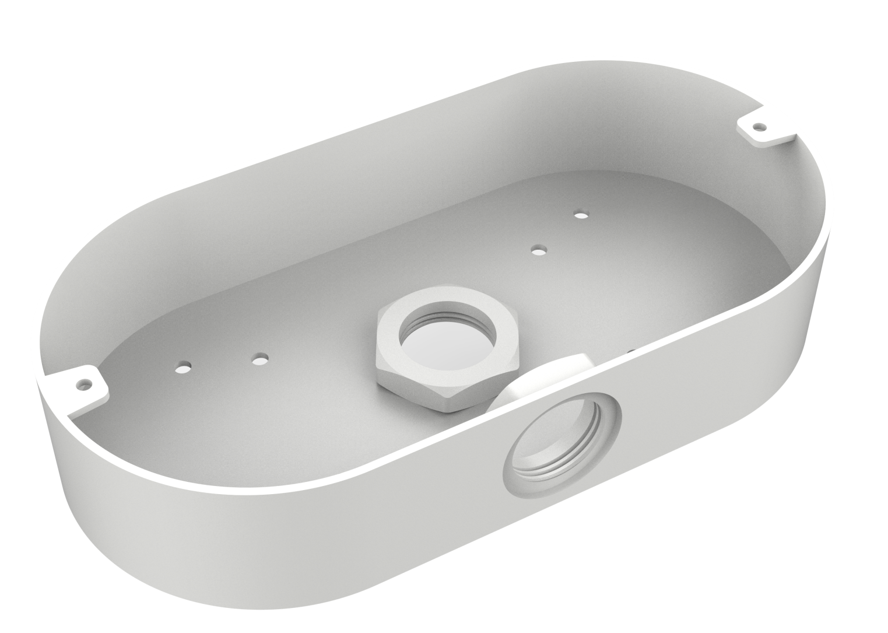 | 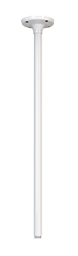

Installation Methods
Junction Box | Pendant Mounting
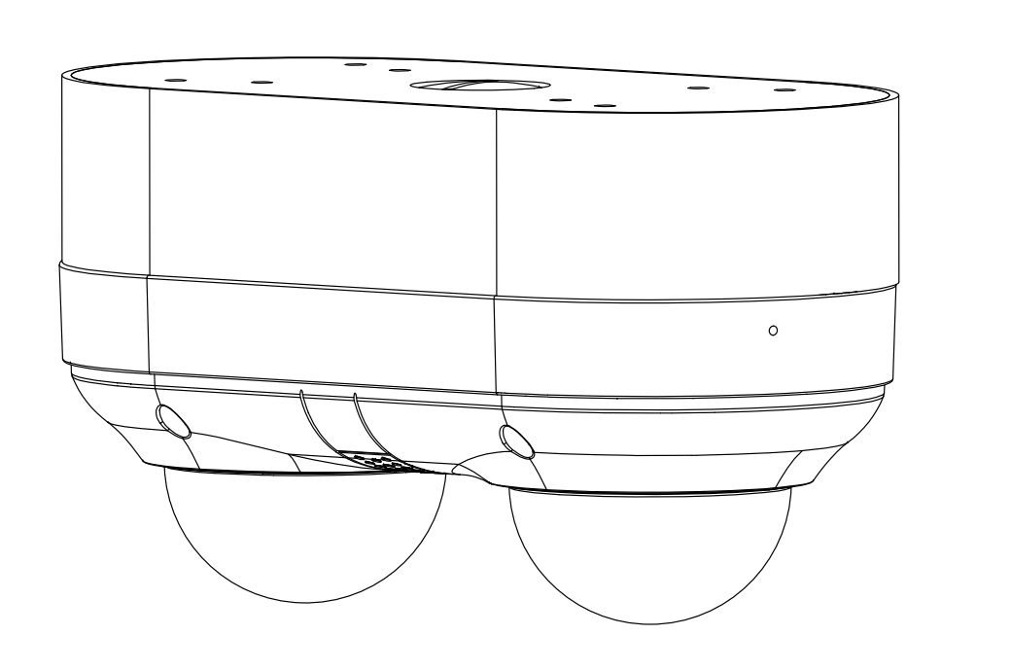 | 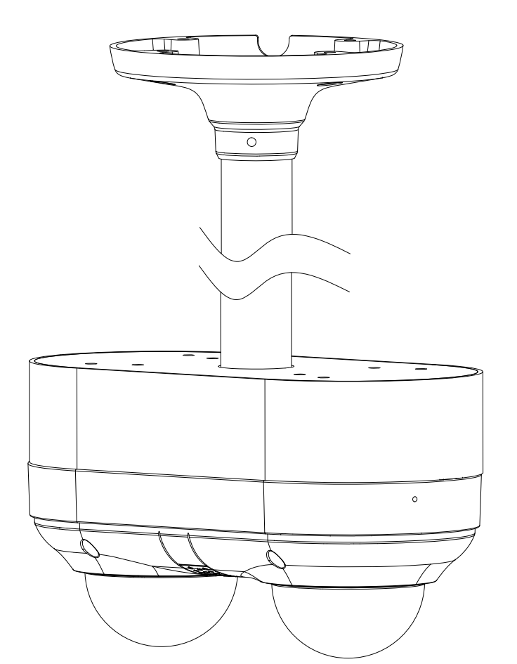
IPC8MSD2R8+JB16 | IPC8MSD2R8+JB16+CMB02

