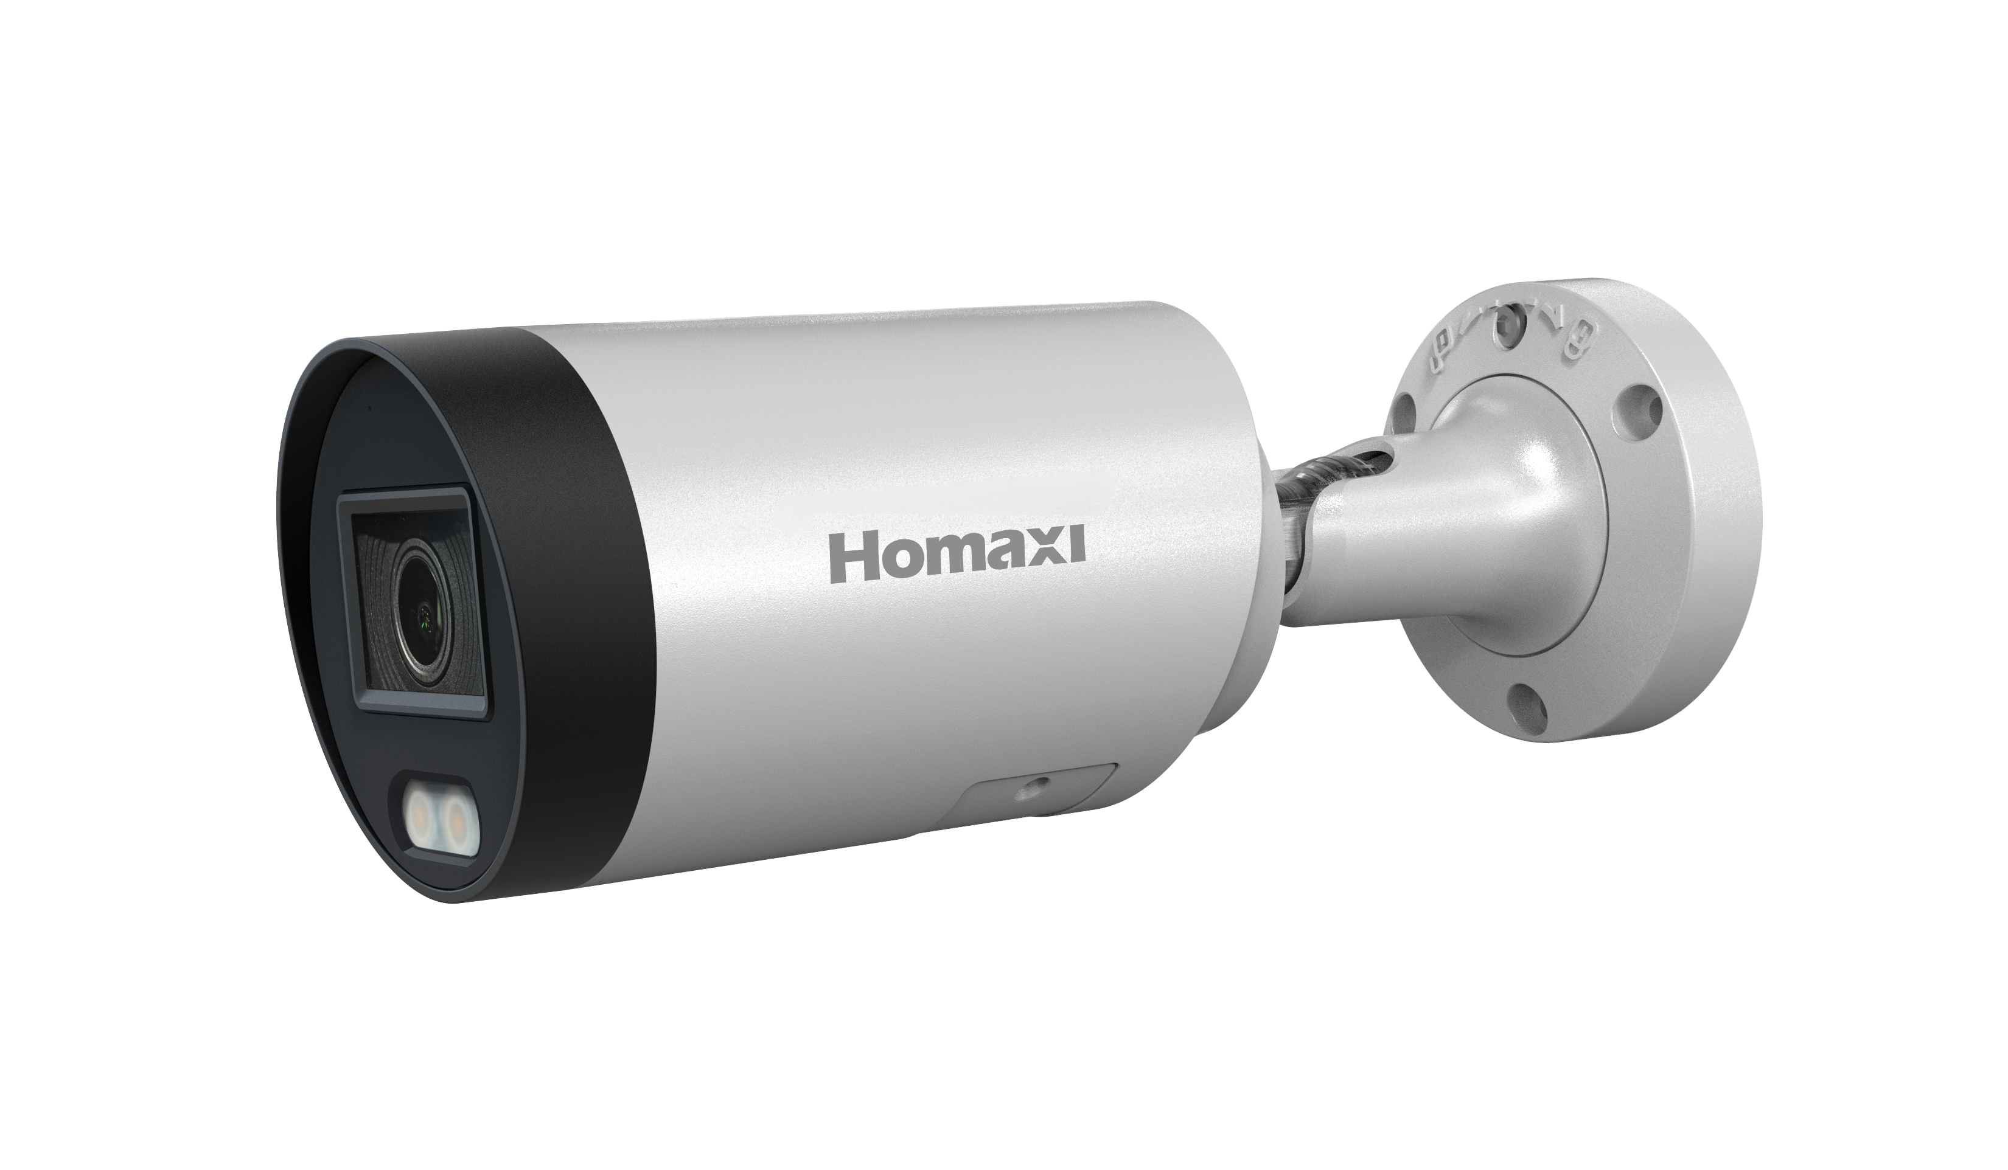

IPC4BF2R4-DL2
4MP AI-ISP Fixed Bullet Network Camera

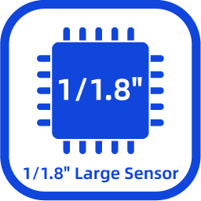

Key Features

- High quality imaging with 4MP resolution
- AI-ISP for excellent noise reduction effect
- 24/7 colorful imaging via AI-ISP technology
- High quality imaging with 4MP resolution, 1/1.8" CMOS sensor and F1.0 large aperture lens
- Efficient H.265+ compression technology
- Clear imaging against strong backlight due to 120 dB WDR technology
- Focus on human and vehicle targets classification
- Water and dust resistant (IP67)
- Built-in microphone for real-time audio security

Dimensions

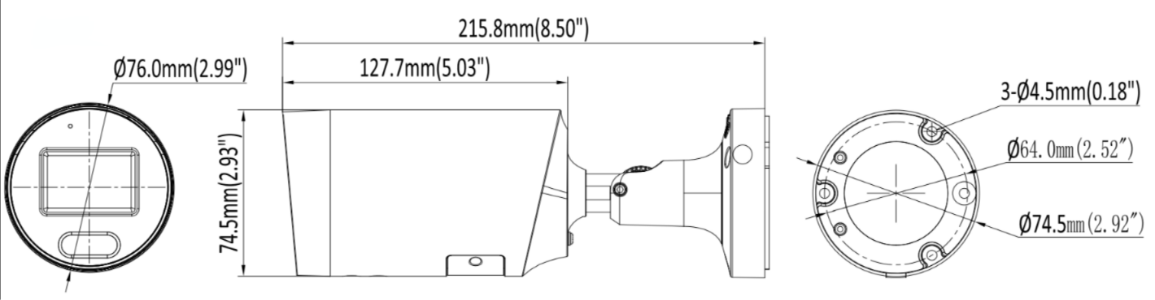

Specification

Camera
Image Sensor | 1/1.8" Progressive Scan CMOS Sensor
Min. Illumination | Color: 0.0005 Lux @ (F1.0, AGC ON) ,0 Lux with Warm light on
Illumination Distance | 30m (warm light)
Smart IR | N/A
Pan/Tilt/Rotation Range | Pan: 0° ~ 360°  Tilt: 0° ~ 90°  Rotation: 0° ~ 360°
Lens
Focal Length | 2.8/3.6 mm
Aperture | F1.0
FOV | 2.8 mm @ F1.0 Horizontal FOV: 110°, Vertical FOV: 59°, Diagonal FOV: 130°  3.6 mm @ F1.0 Horizontal FOV: 95°, Vertical FOV: 51°, Diagonal FOV: 113°
Lens Mount | M16
DORI
DORI | 2.8 mm @ F1.0, D: 57 m, O: 23 m, R: 11 m, I: 6m  3.6 mm @ F1.0, D: 68 m, O: 27m, R: 14m, I: 7m
Compression Standard
Video Compression | H.264/H.264+/H.265/H.265+/MJPEG
H.264 Codec Profile | Base/Main/High profile
H.265 Codec Profile | Main Profile
Video Bit Rate | 11 Kbps ~ 10Mbps
Triple Streams | Support
Audio Compression | G.711A, G.711U
Audio Bit Rate | 64 Kbps
Image
Max. Image Resolution | 4M (2688 × 1520)
Main Stream | 50Hz: 20fps 4M (2688 × 1520)  25fps 4M (2560 × 1440)  25fps 1080P (1920 × 1080)  60Hz: 20fps 4M (2688 × 1520)  30fps 4M (2560 × 1440)  30fps 1080P (1920 × 1080)
Sub Stream | 50Hz: 25fps 720P (1280 × 720)  25fps D1 (704 × 576) ,25fps CIF(352 × 288)  60Hz: 30fps 720P (1280 × 720)  30fps D1 (704 × 480) , 30fps CIF (352 × 240)
Third Stream | 50Hz:25fps CIF (352 × 288)  60Hz: 30fps CIF (352 × 240 )
Image Setting | Brightness/Contrast/Saturation/Hue/Sharpness
Shutter Time | Auto/Manual, 1/3 ~ 1/100000s
Day/Night | IR Cut Filter
Wide Dynamic Range | 120dB
Digital Noise Reduction | 2D/3D DNR
BLC | Support
HLC | Support
ROI | Support
Rotate | Support
Smart Feature
Basic Event | Motion detection, video tampering
Smart Event | Smart motion detection, line crossing, intrusion, region entrance, region exiting (support alarm triggering by specified target types (human and vehicle) )
Face Detection | N/A
Network
Network Storage | NAS (NFS, SMB/CIFS)
Protocols | TCP/IP, ICMP, HTTP, HTTPS, FTP, DHCP, DNS, DDNS, RTP, RTSP, RTCP, NTP, IGMP, UPnP, SMTP, UPnP-TM, Cloud
System Compatibility | Onvif (Profile S, Profile G, T) , SDK
Security | HTTPS encryption, IP address filter, basic and digest authentication for HTTP/HTTPS, TLS 1.1/1.2, WSSE and digest authentication for Open Network Video Interface
User | Up to 40 users
Web Browsers | Plug-in required live view: IE 10, IE 11  Local service: Chrome 57.0+, Firefox 52.0+
Mobile Surveillance | IOS, Android
Active Deterrence
Red/Blue Light Warning | N/A
Sound Warning | N/A
Interface
Communication Interface | 1 RJ45 10 M/100 M self-adaptive Ethernet port
On-board Storage | Up to 256GB
MIC | Support
Speaker | N/A
Audio I/O | N/A
Alarm I/O | N/A
Reset Button | Support
General
Operating Conditions | (-40°C ~ 60°C) (-40°F ~ 140°F)  Humidity 95% or less (non-condensing)
Power Supply | DC12V ± 25%
POE | PoE (802.3 af)
Power Consumption | MAX. 8W
Protection Level | IP67
Material | Metal
Dimensions | Φ76 × 215.8 mm
Gross Weight | 900 g

Accessory
Optional
AC-JB02 | AC-PM03 | AC-CMB02 | AC-PC06
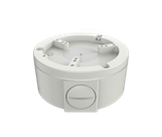 | 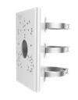 | 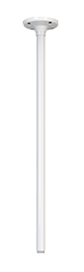 | 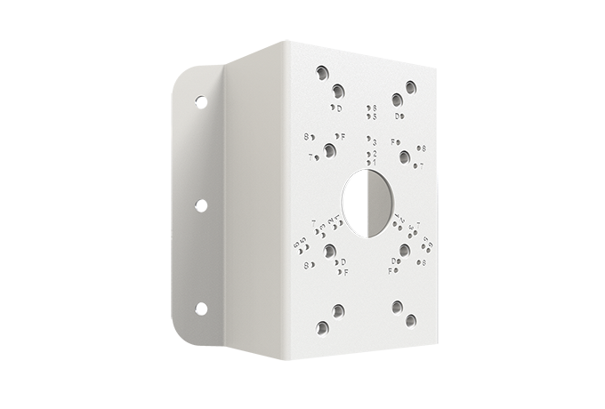

Installation Methods
Junction Box | Pendant Mounting | Vertical Pole Mounting | Corner Mounting
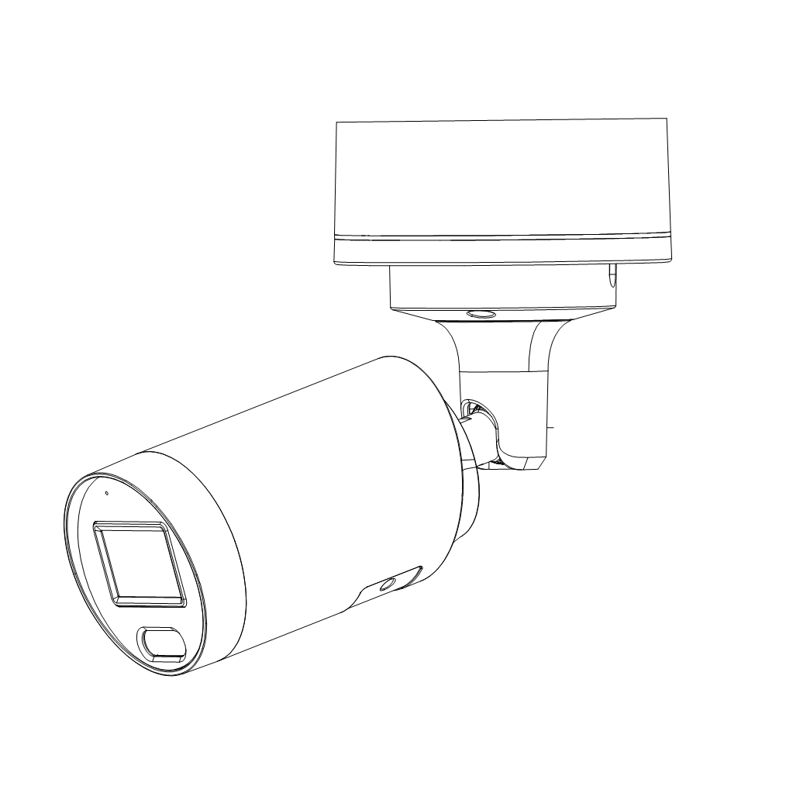 | 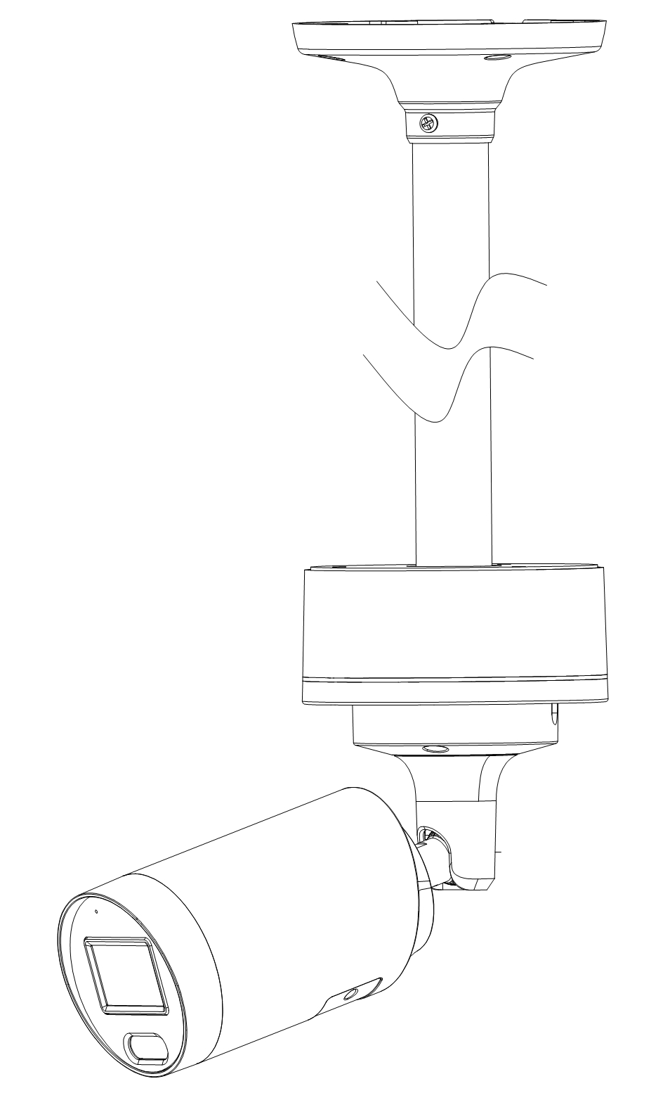 | 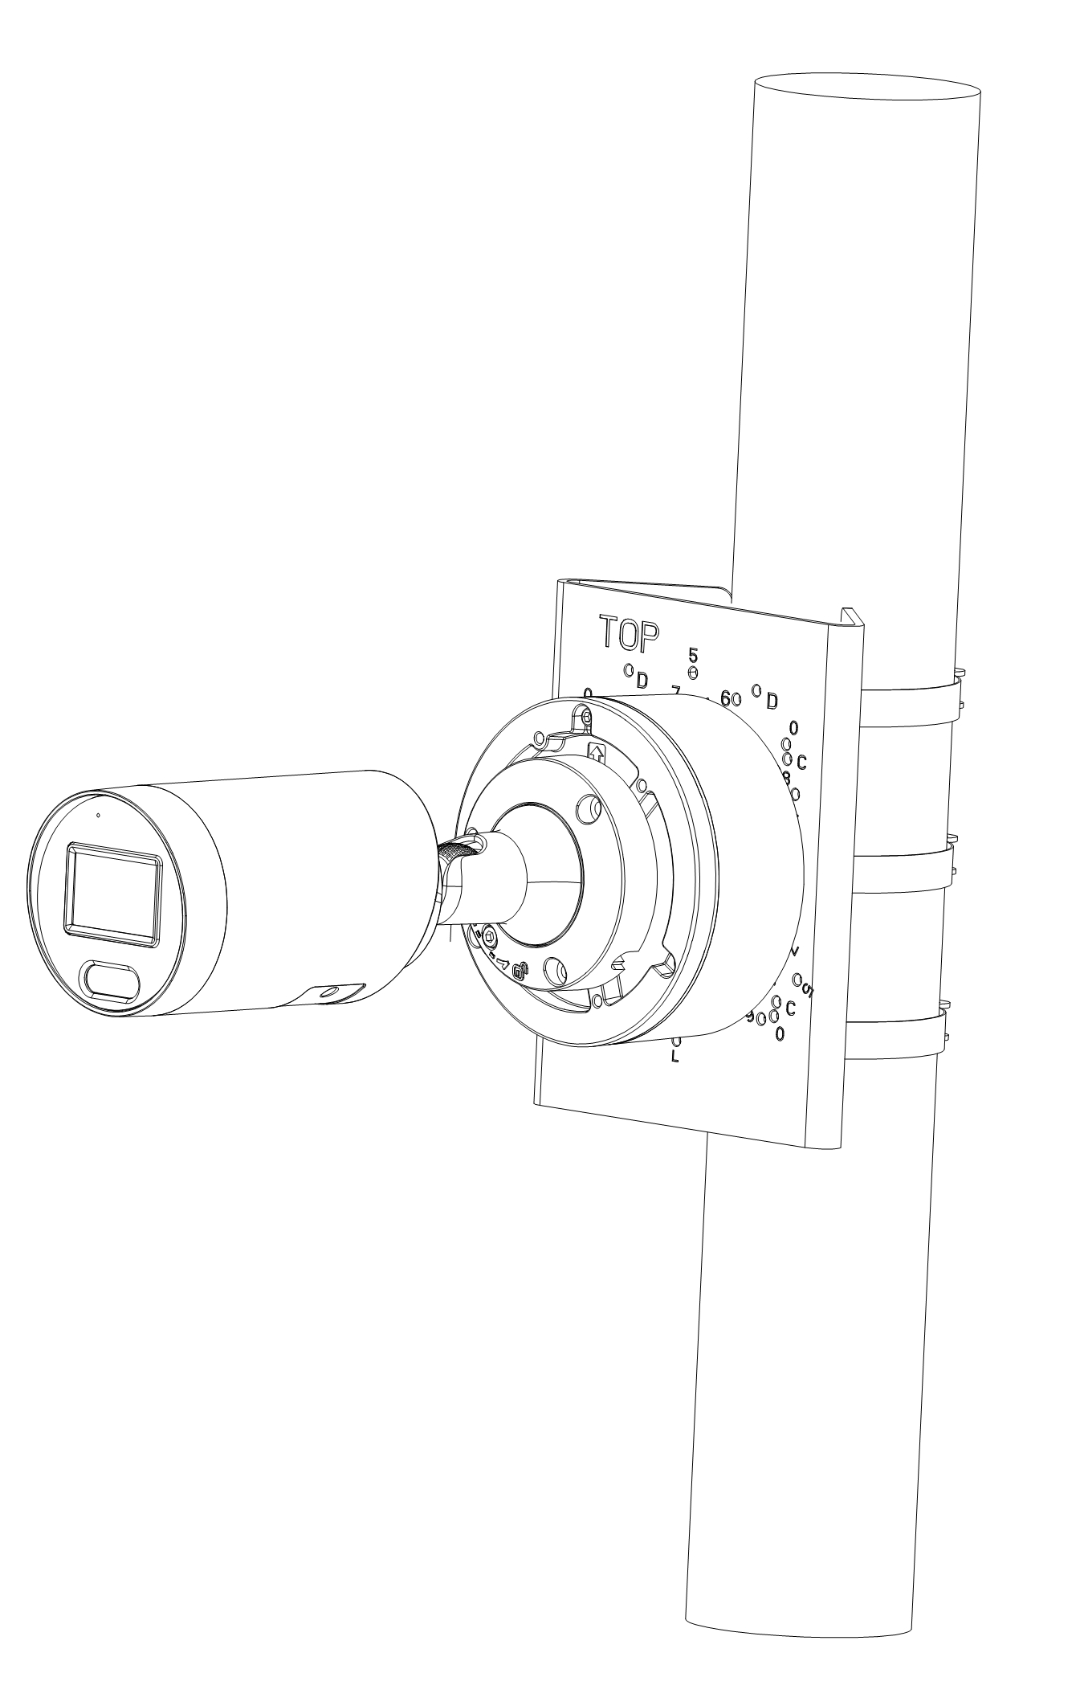 | 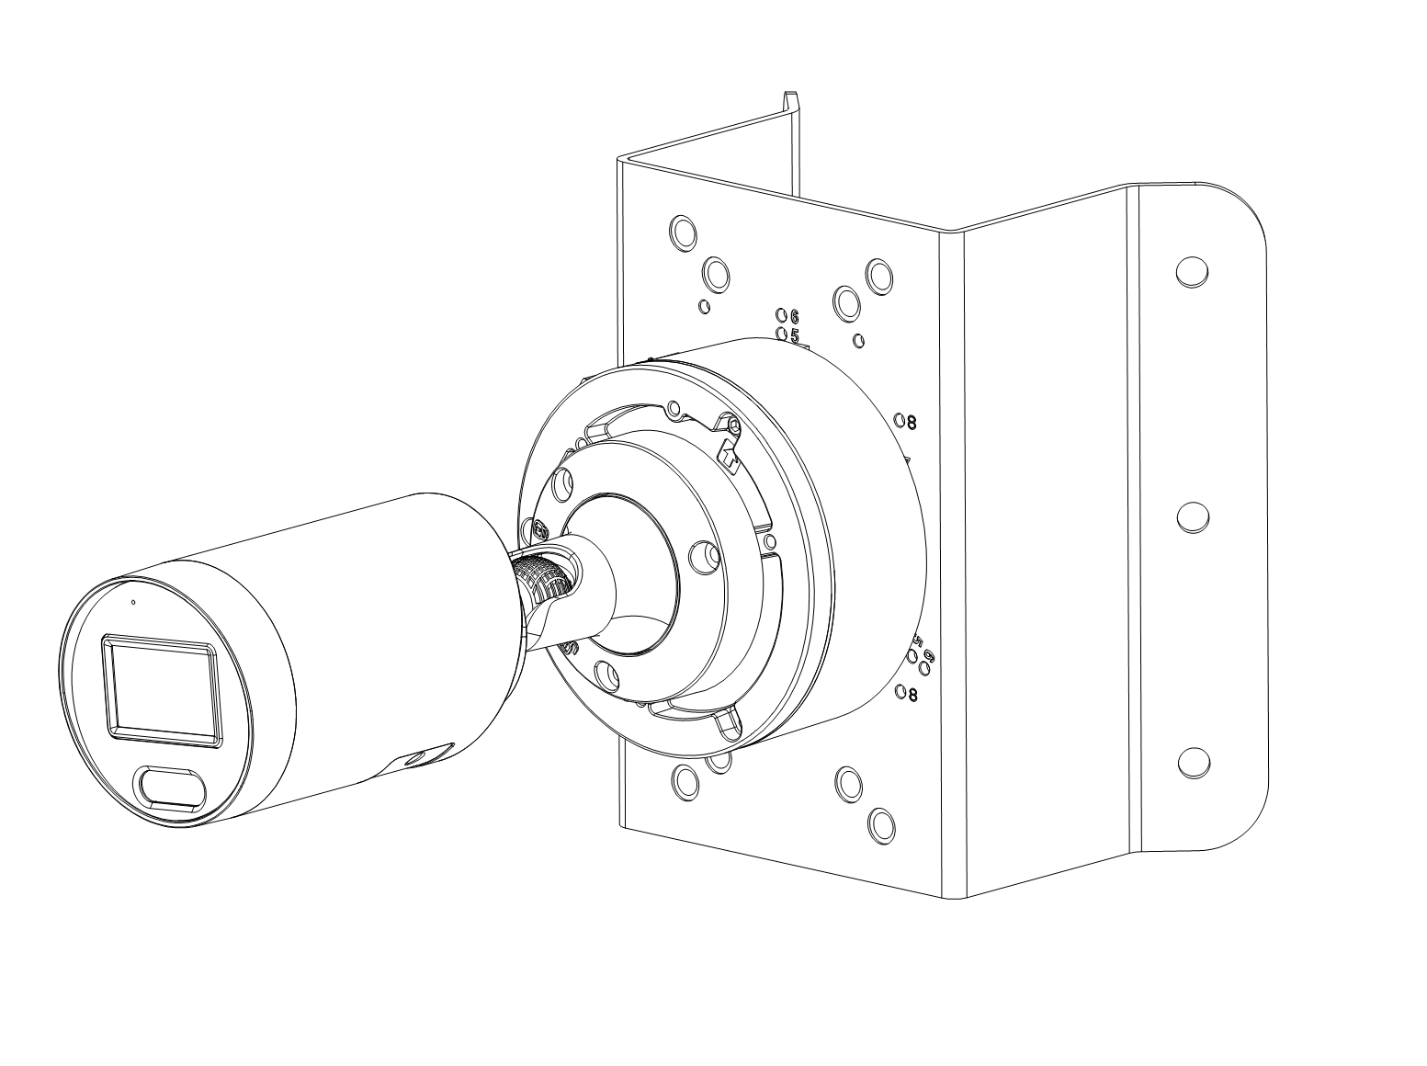
IPC4BF2R4+JB02 | IPC4BF2R4+JB02+CMB02 | IPC4BF2R4+PM03 | IPC4BF2R4+JB02+PC06

